**SW Engineering CSC648/848 Fall 2020**

**Team 01 Section 02**

**Code: “Coronafirus”**

**Team 01 Members:**

Thomas Abadines (Team Lead) (tabadines@mail.sfsu.edu)

Vito Gano (Project Manager) (vgano1@sfsu.edu)

Souhib Trabelsi (Github Master)

Junhao Zhai (Backend)

Amily Wu (Document Master)

Trung-Duong Pham-Vu (Front End)

[**http://coronafirus.team:3001/**](http://coronafirus.team:3001/)

**11/10/2020**

**2) Product summary:Please copy this section from M4 (it is put here again for completeness of M5**

Product: Coronafirus, It combines two of our main focuses, Coronavirus and Wildfires in California.

Itemized list

1. View Interactive Map (Search) using Google Maps API
2. View Data from using Interactive Map, users can click on counties and data will show up for that county.
3. Login (Covid Director), Directors should be able to login with a premade account.
4. Login (Fire Director), Directors should be able to login with a premade account.
5. Login (Administrator), Admin should be able to login with a premade account.
6. Covid Metrics Input (Confirmed), director will be able to enter covid confirmed cases.
7. Covid Metrics Input (Recovered), director will be able to enter covid recovered.
8. Covid Metrics Input (Death), director will be able to enter covid deaths.
9. Fire Metrics Input (Acres Burned), director will be able to enter acres burned.
10. Covid Alert, County Health director can send alerts to their county.
11. Fire Alert, Fire Director can send an alert to their county.
12. Posting Items and Data (Administrator), items will need to be approved by the administrator before posting it online
13. Register to get alerts (Users), users can get alerts using their email.

What is UNIQUE about our product?

It’s a website that has an interactive map that when you click on one of the county areas, information about it, either covid or wildfire, will pop up. We have a toggle button that can switch the UI focus to either Covid or Wildfire, with Covid having a green-based theme and wildfire having a red-based theme to differentiate. A possible useful feature in our product is getting alert messages. If the general user wants, we have an optional button in our navigation bar to get alerts by signing up with their email and selecting their county, they are not required to make an account or password in our website to receive alerts. Since our website isn’t a phone app, it’s not as convenient to receive alerts through our website, so email would be more easily accessible especially because most people have smartphones and a default email app available. For directors they have premade accounts and we made the tasks they need to do very simple with our UI. We focus our product on usability to make it simple for our users to read data related to wildfire and coronavirus. In a few clicks a user can see data related to his county.

URL to our product : <http://coronafirus.team:3001/>

**3) Milestone documents–M1-M4**

Feedback Summary Report

M1

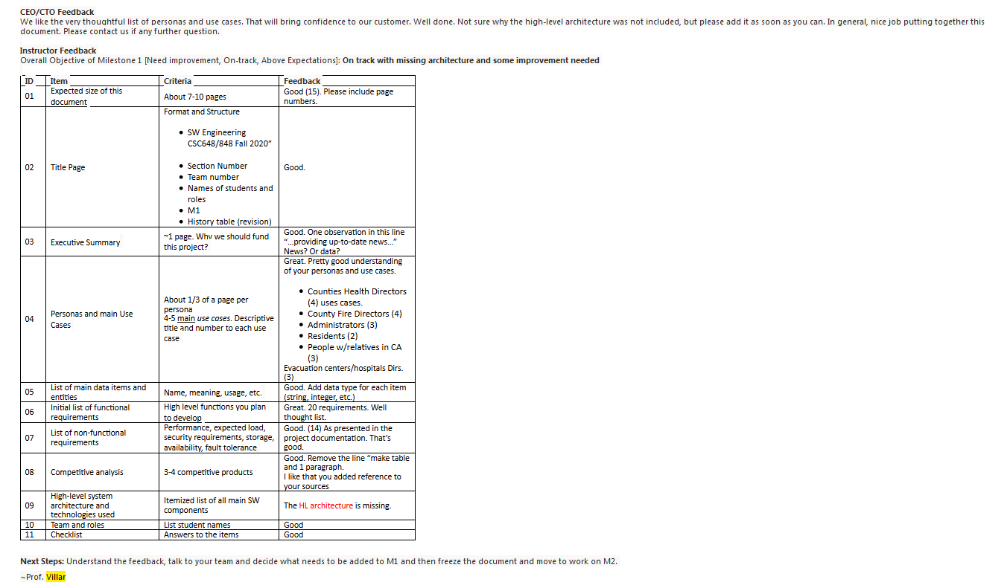

M2

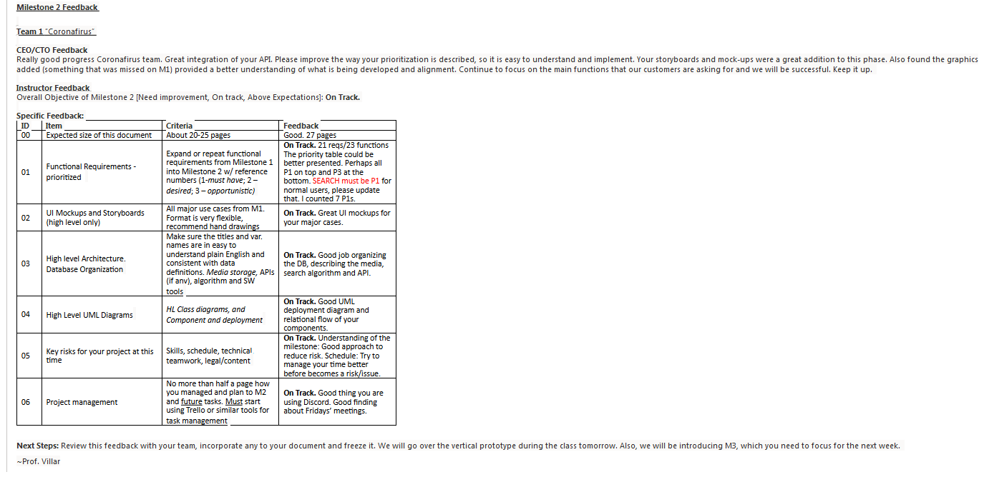

M3

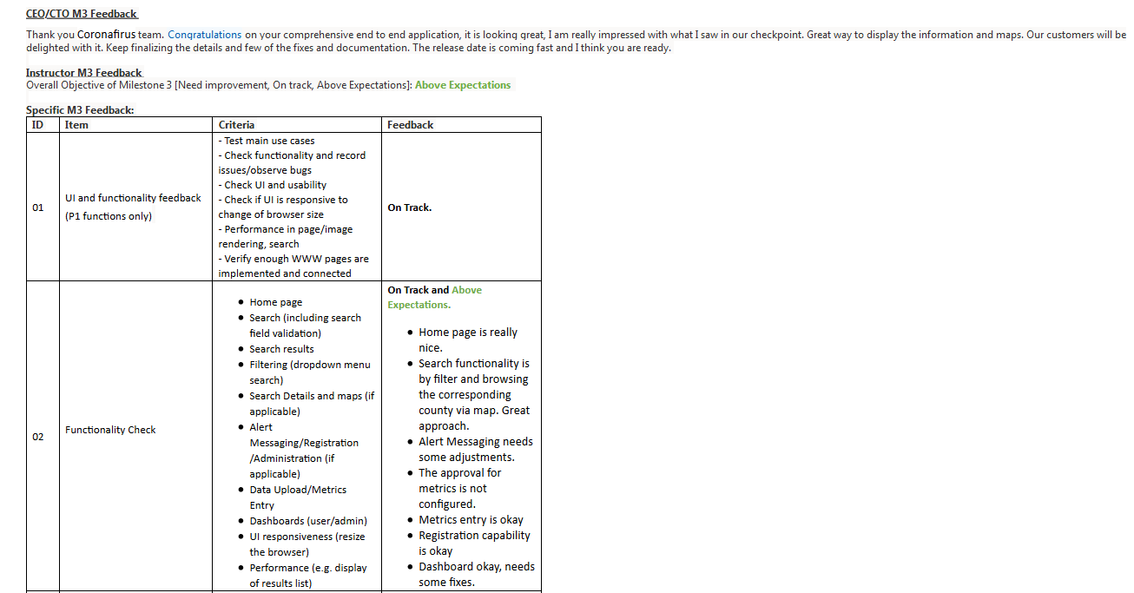

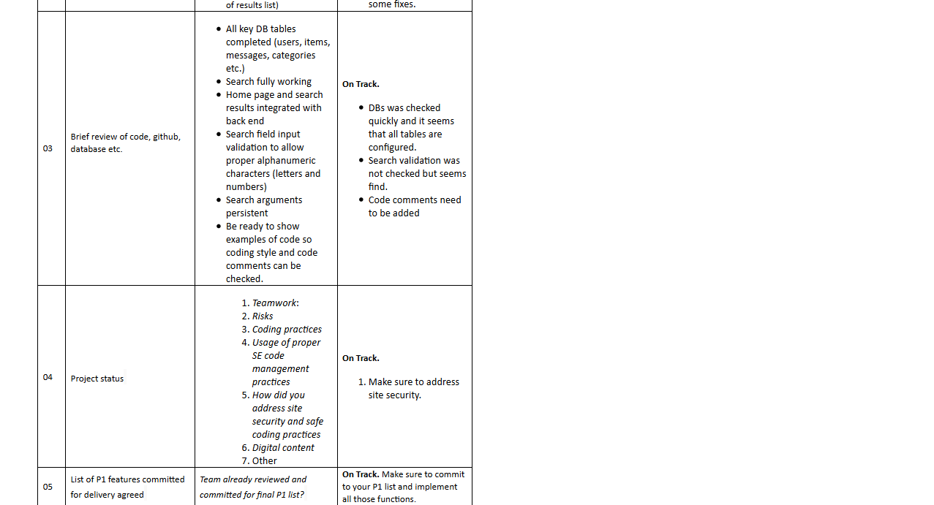

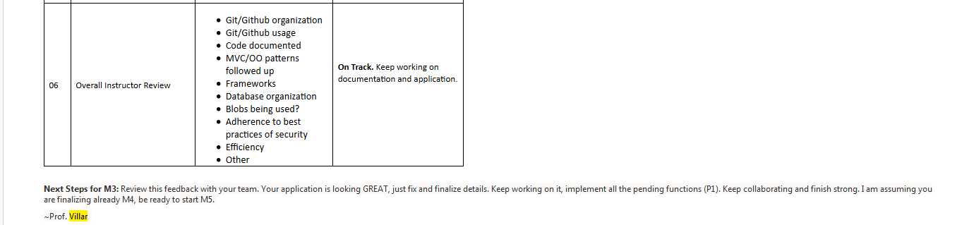

M4

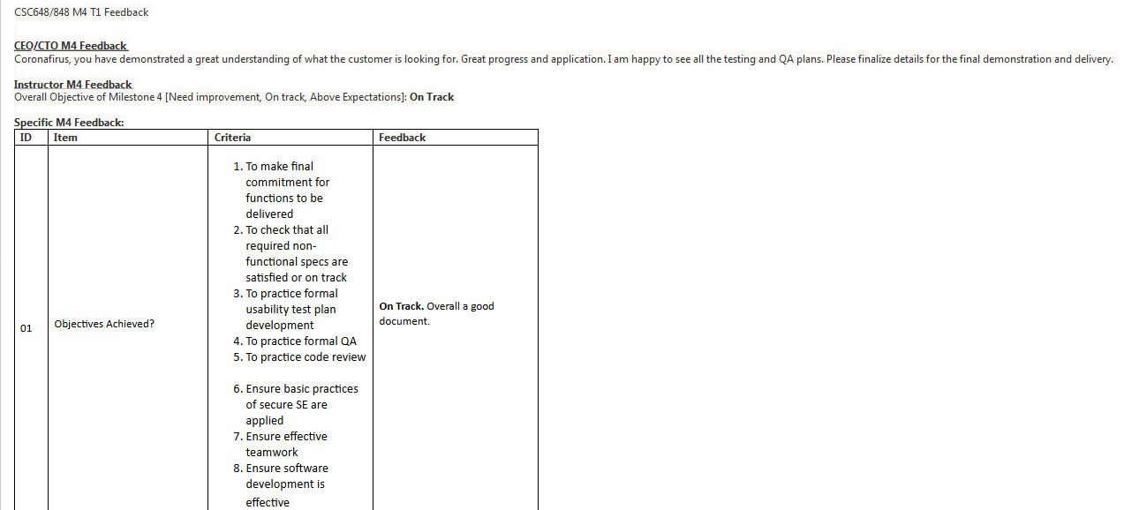

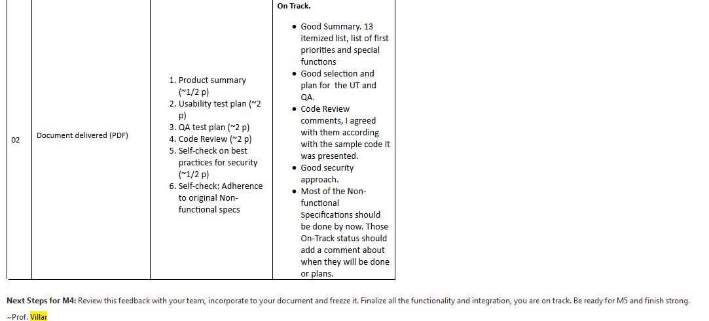

**4) Screen Shots of actual final product as shown in the demo, one per page**

Section title: “Product Screen Shots”contains copies of all final screen shots of your final product(1 per page).

Home Page

Fire

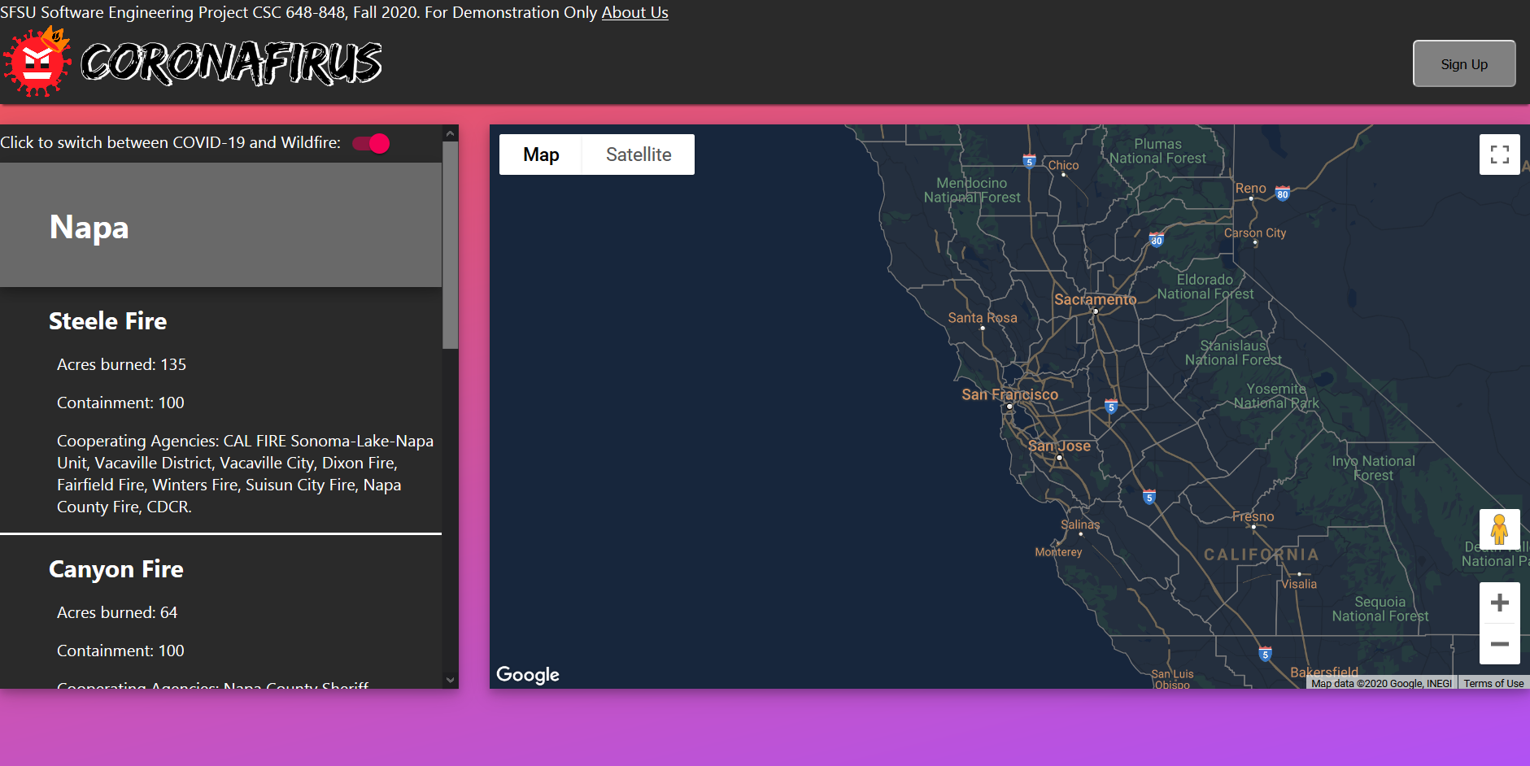

Covid

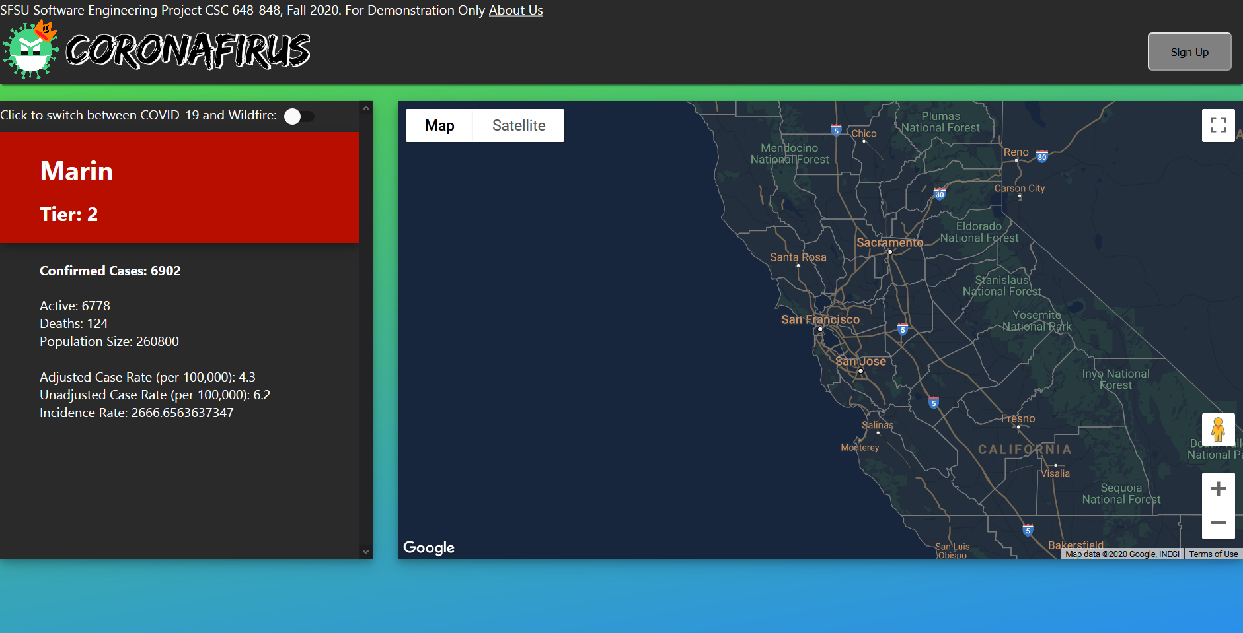

Login Page

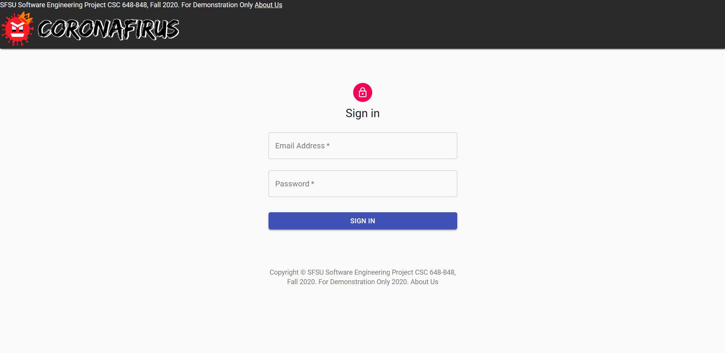

Alert Subscription Page

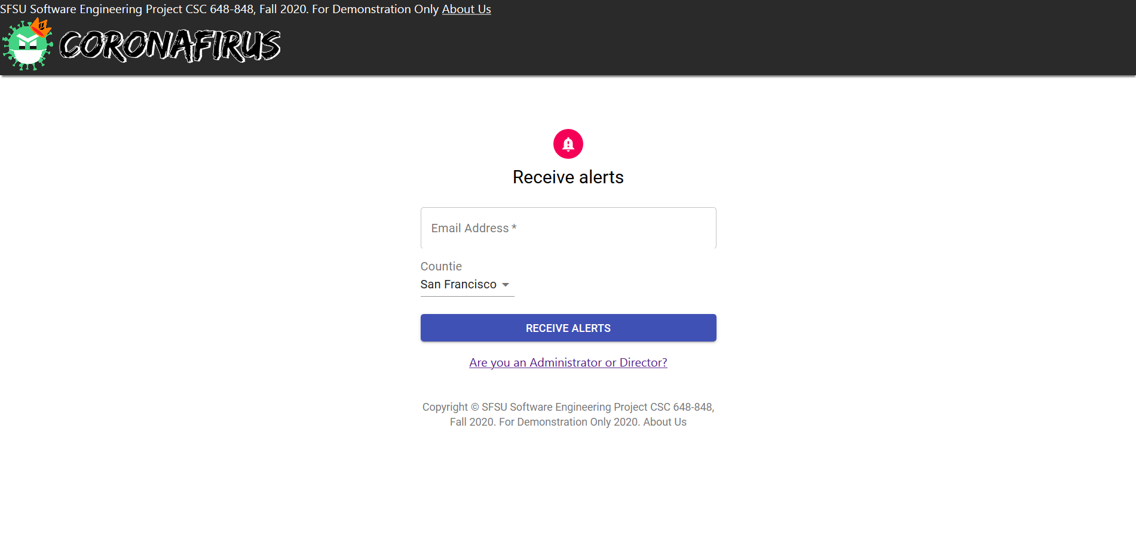

Admin Pages

Approve or Disapprove Alerts

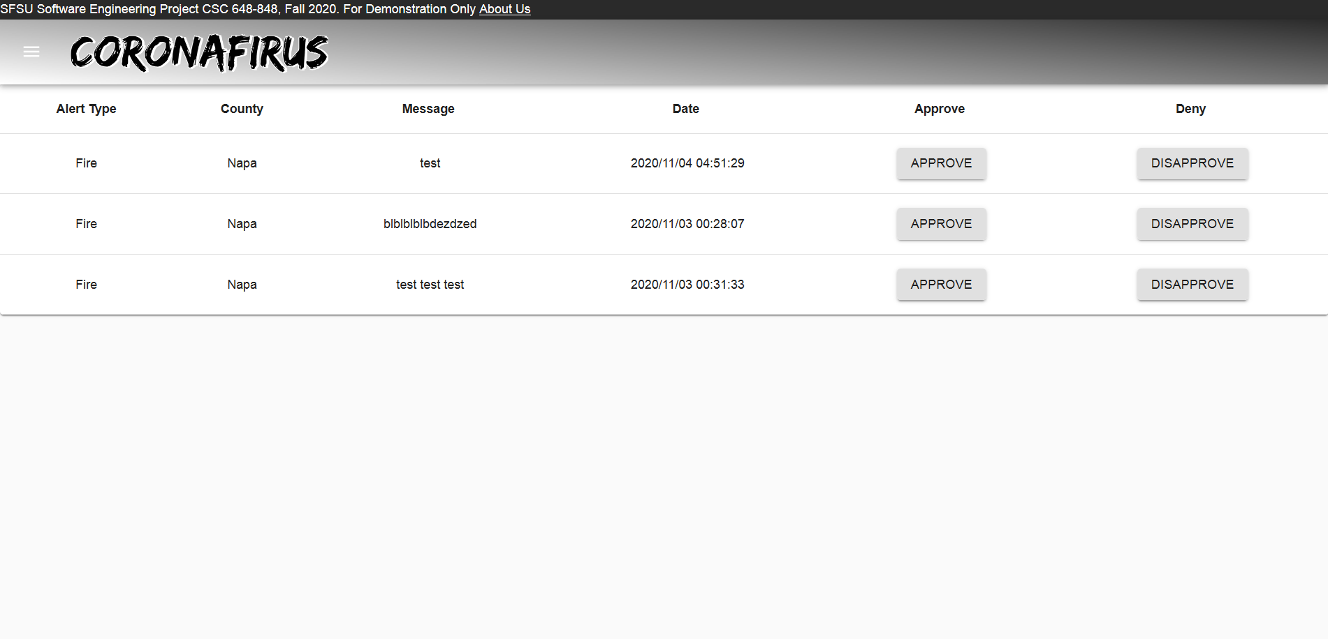

Approve or Disapprove Data Edit

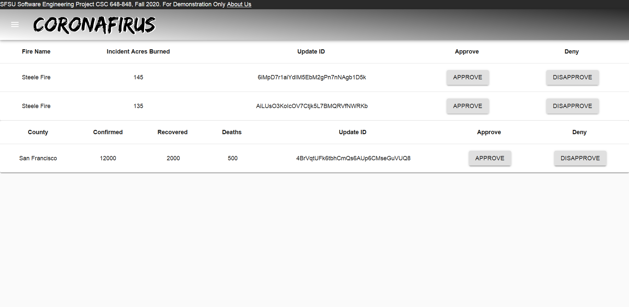

Approve or Disapprove Add entry

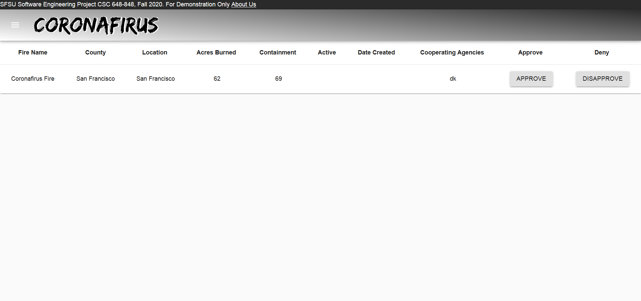

View Map

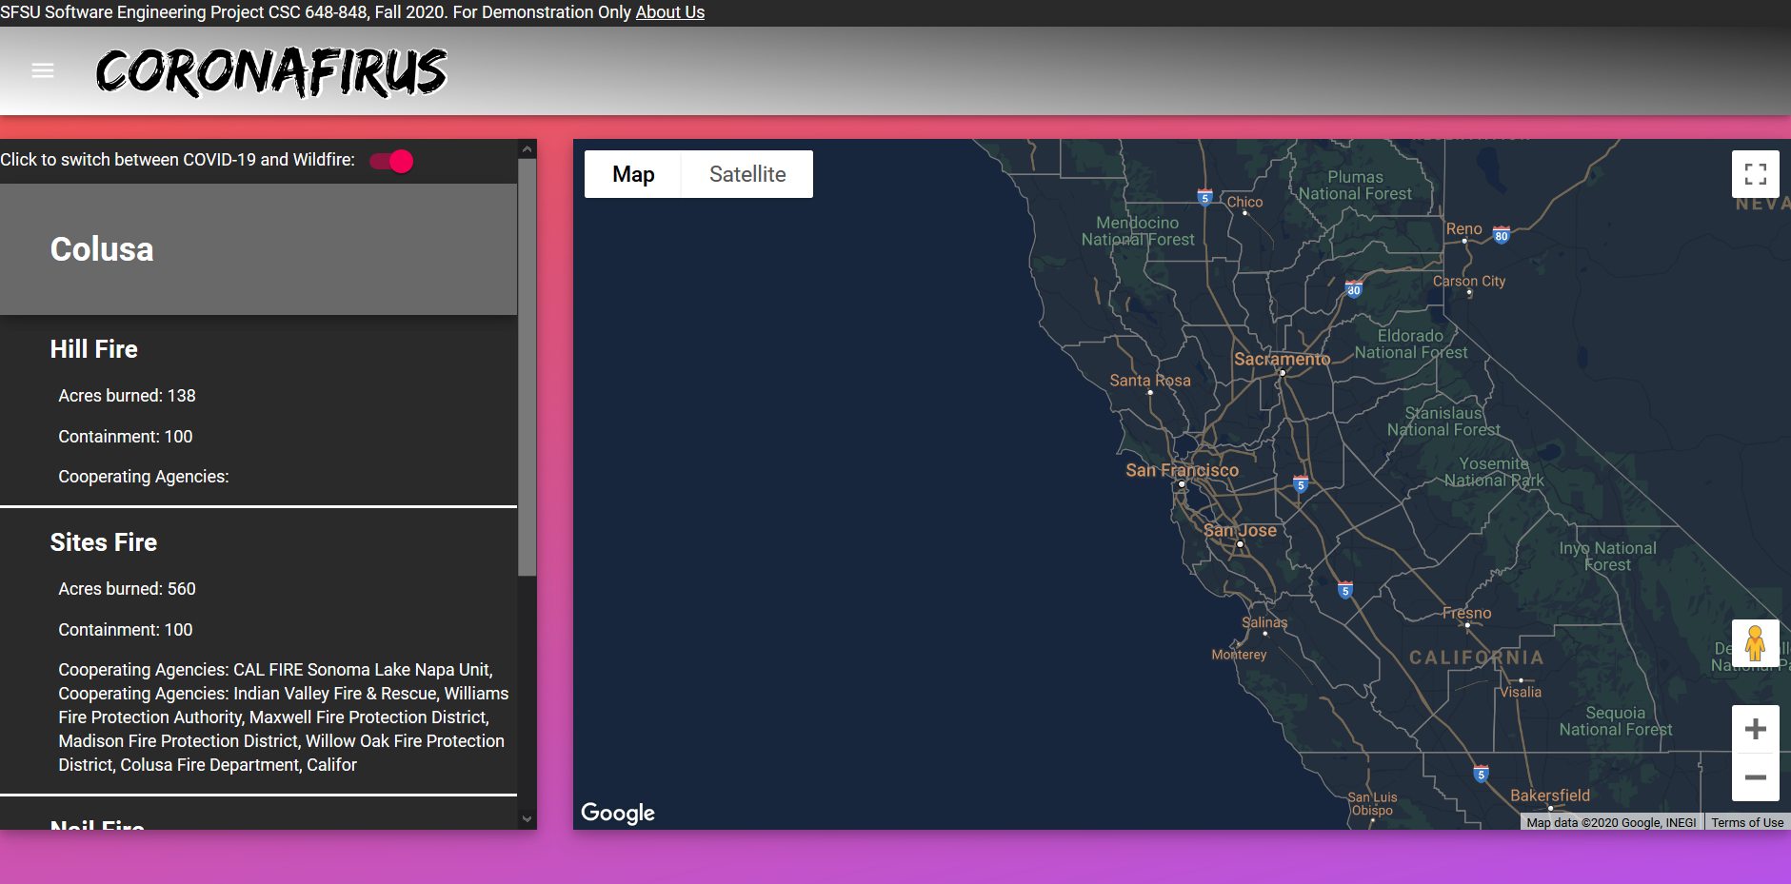

Fire Director Pages

Alerts

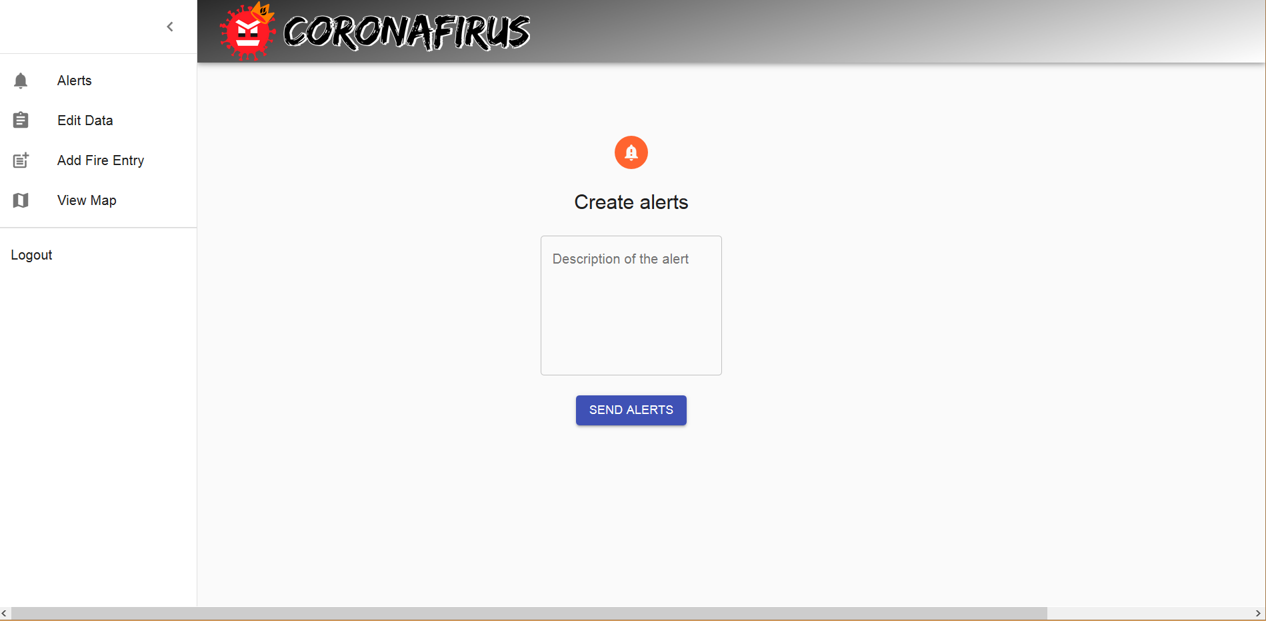

Edit Data

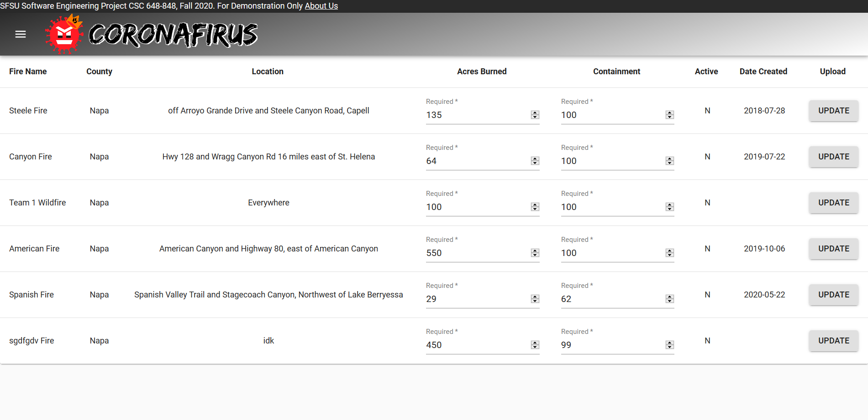

Add Fire Entry

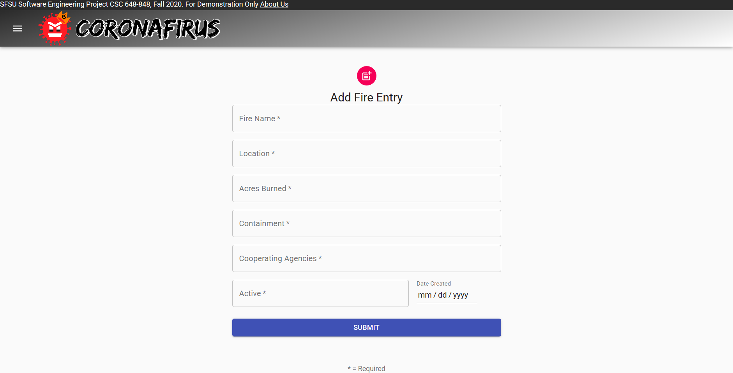

View Map

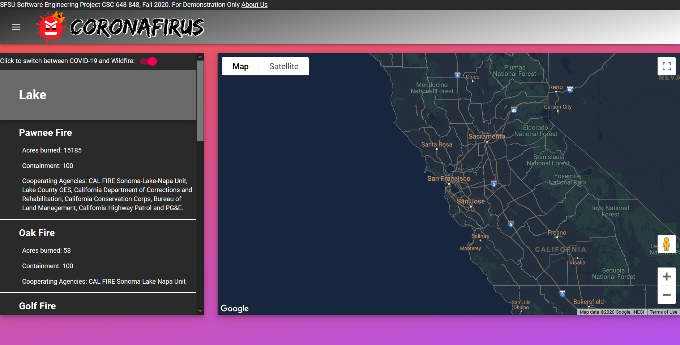

Covid Admin Pages

Create Alerts Page

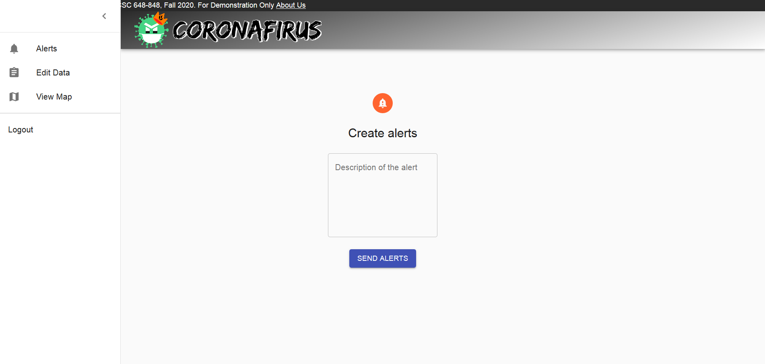

Edit data Page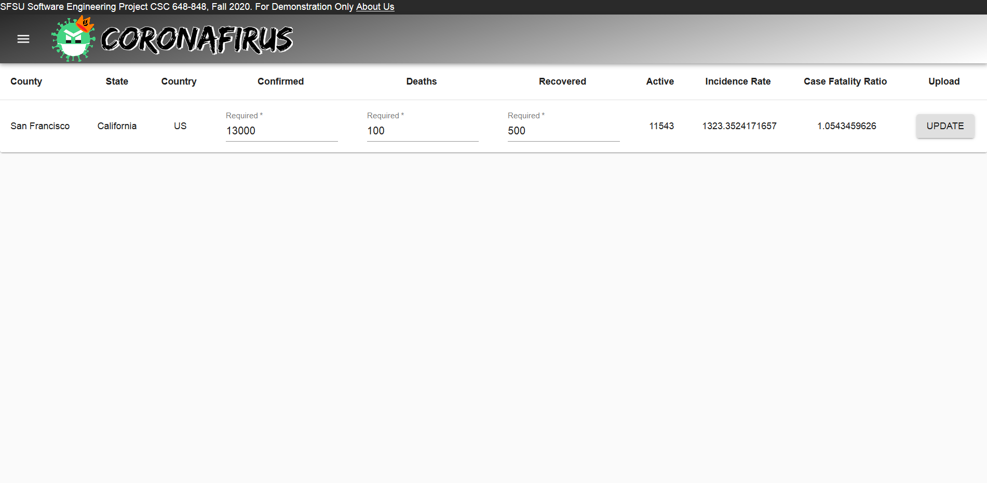

View Map Page

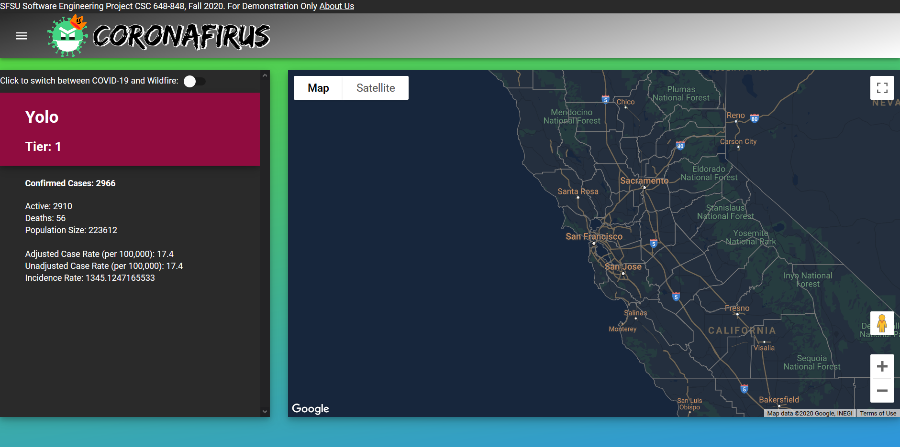

About Page

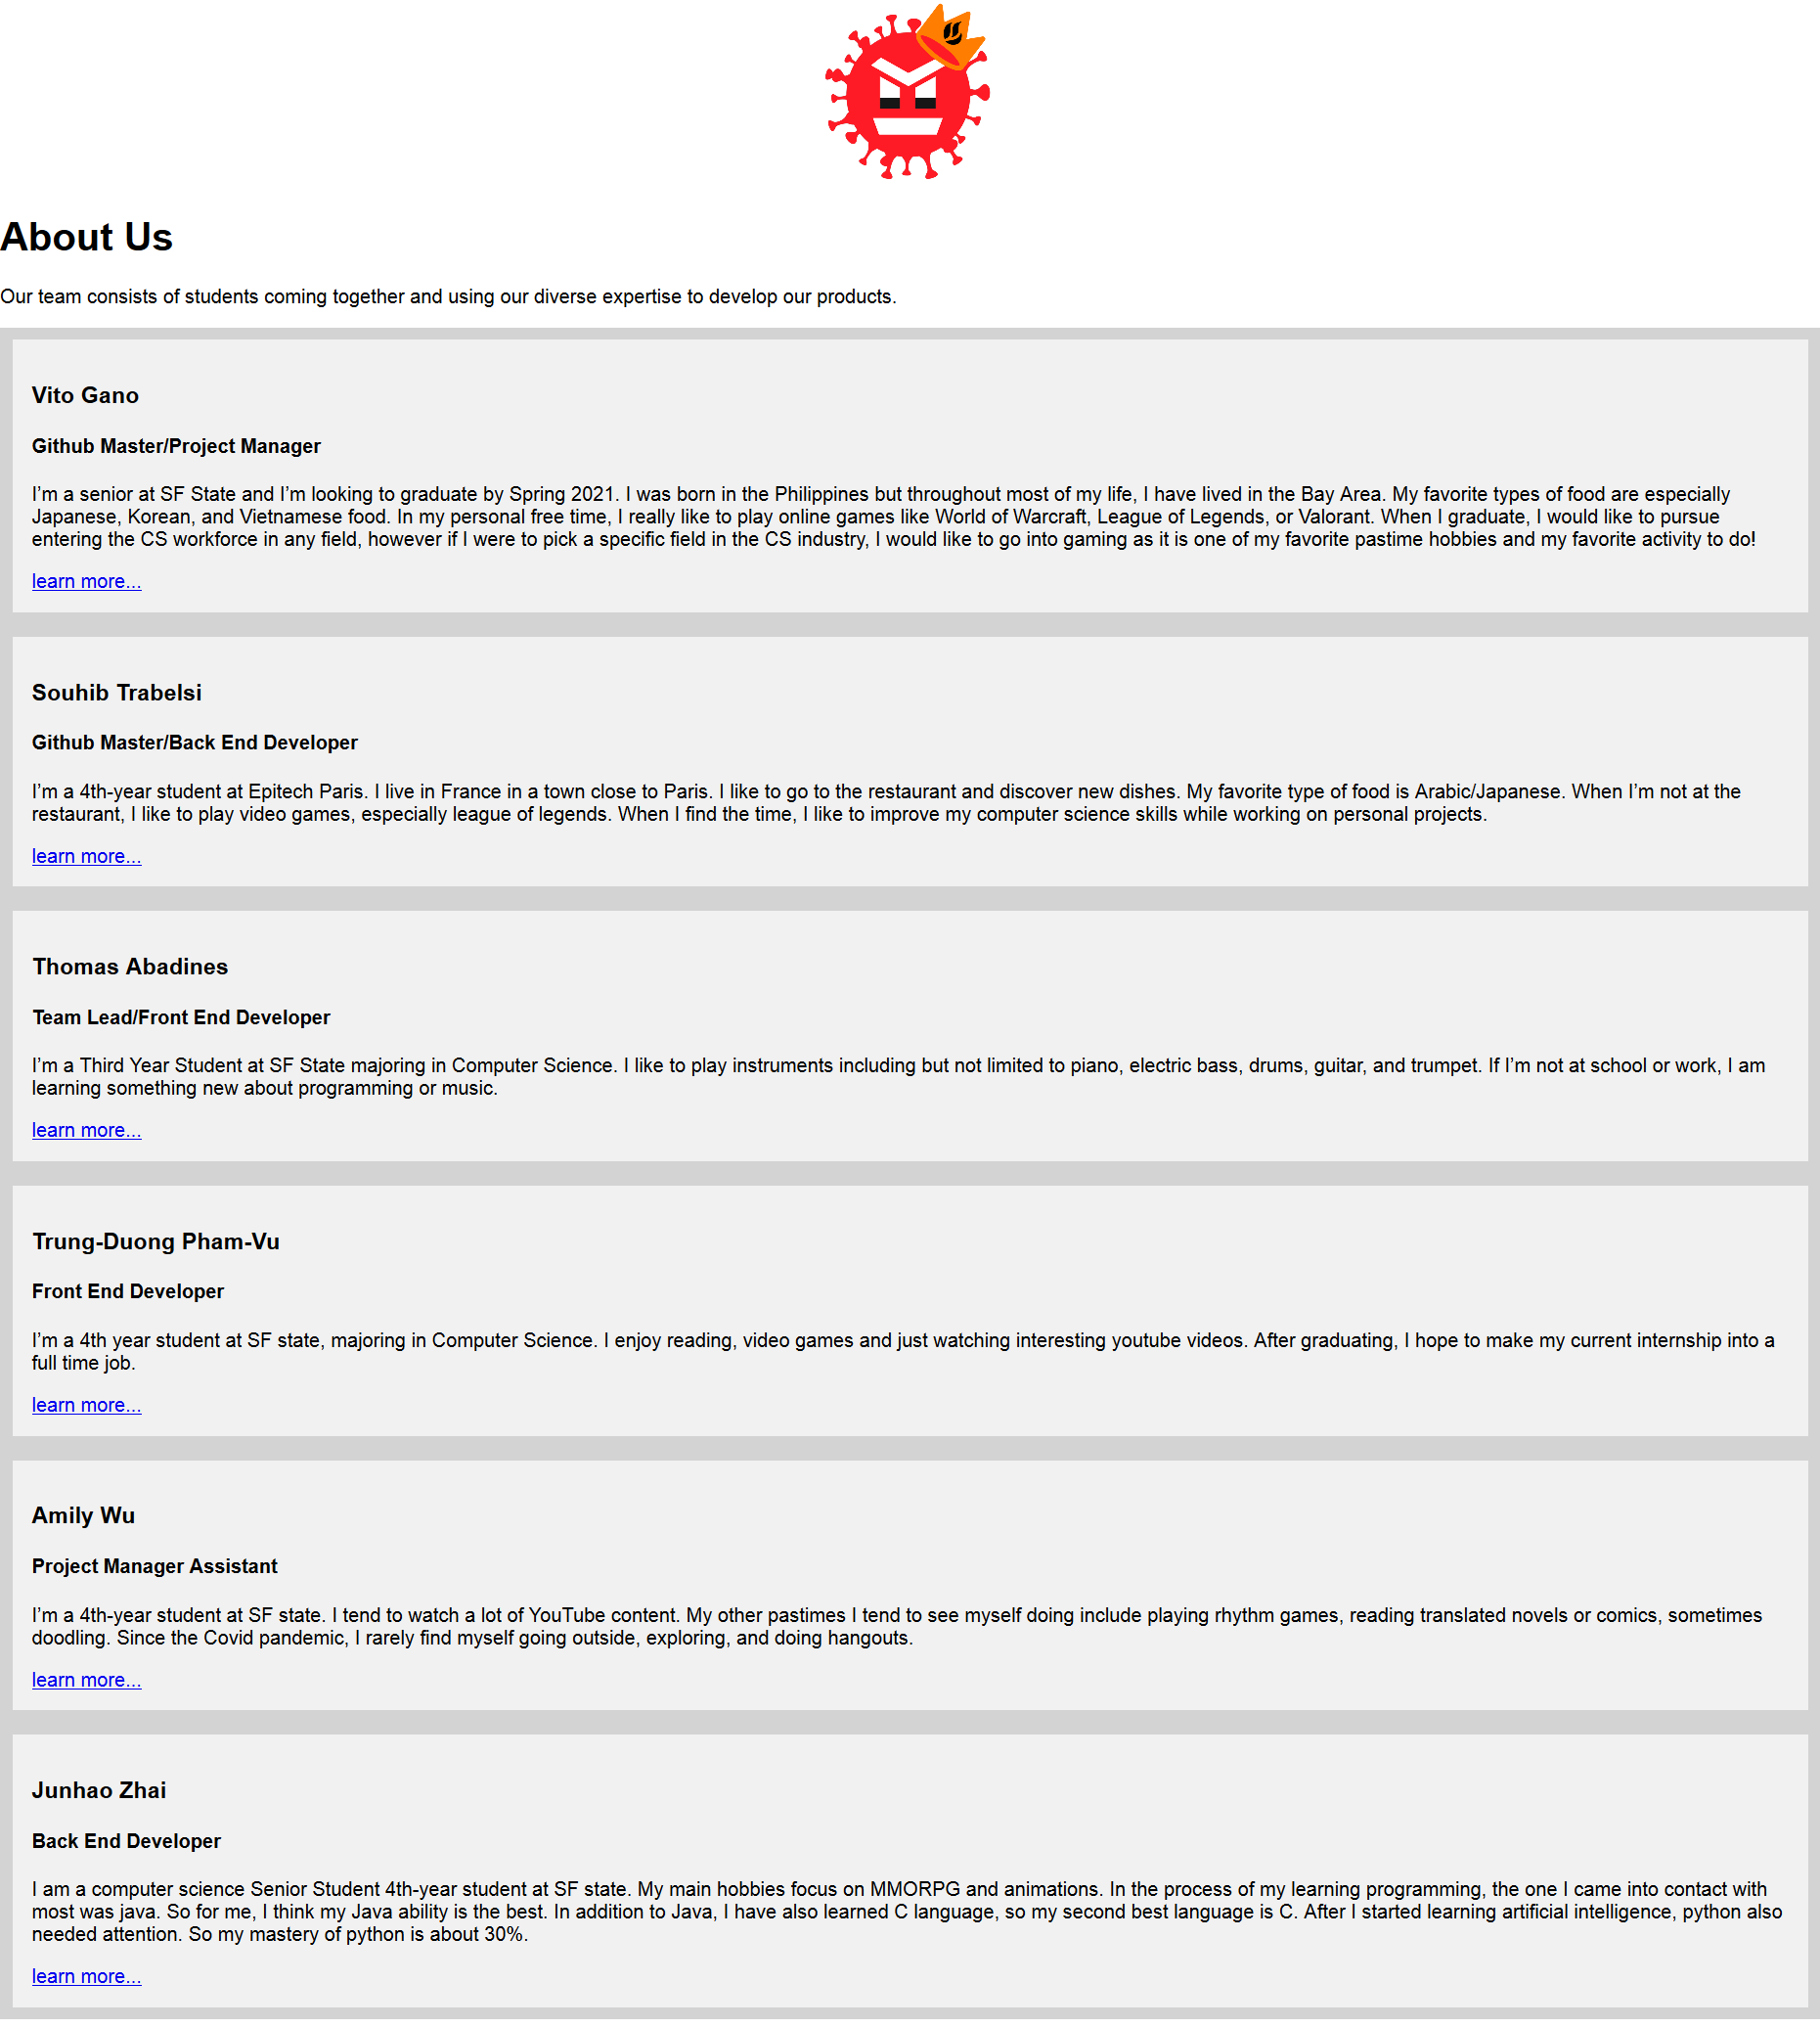

**5) Screenshots of keyDB tables (1-2 pages)**

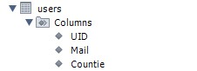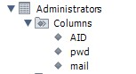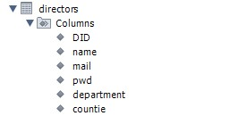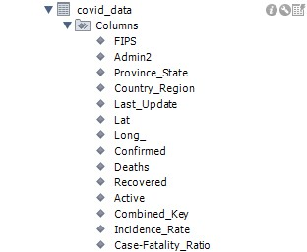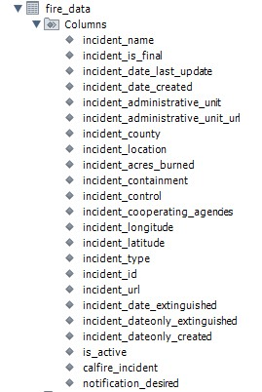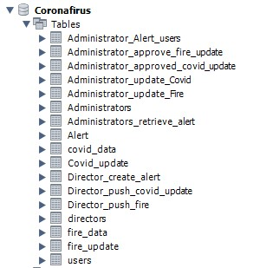**6) Google analytics plot for your WWW site or plugins or API used (1 page)**

No analytics

We used google maps API to display the map with data inside a map

We retrieved the data from these websites

<https://github.com/CSSEGISandData/COVID-19/tree/master/csse_covid_19_data>

<https://www.fire.ca.gov/incidents/>

**7) Screen shot(s) of your task management system** (like Trello) showing a snapshot of your project management

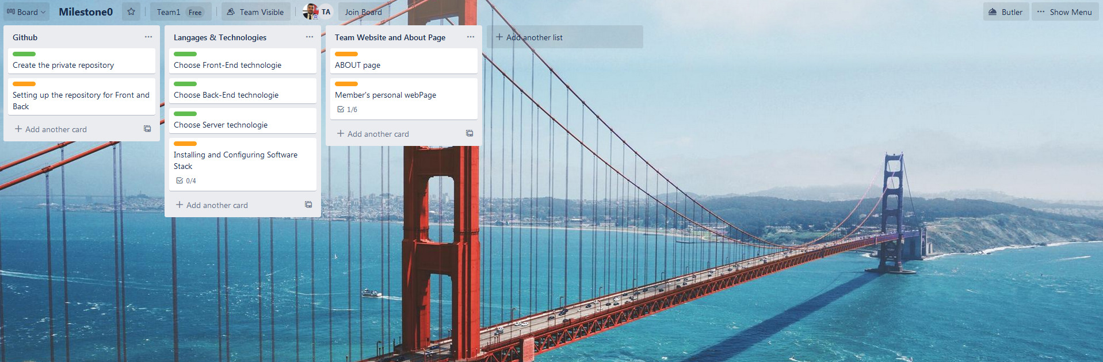

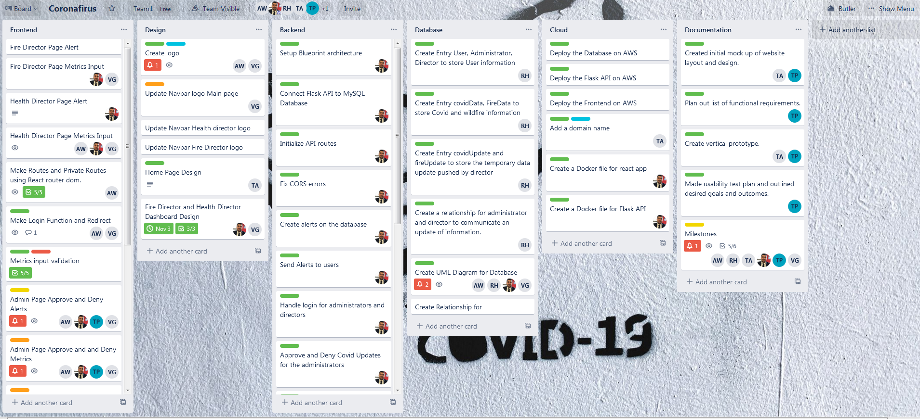

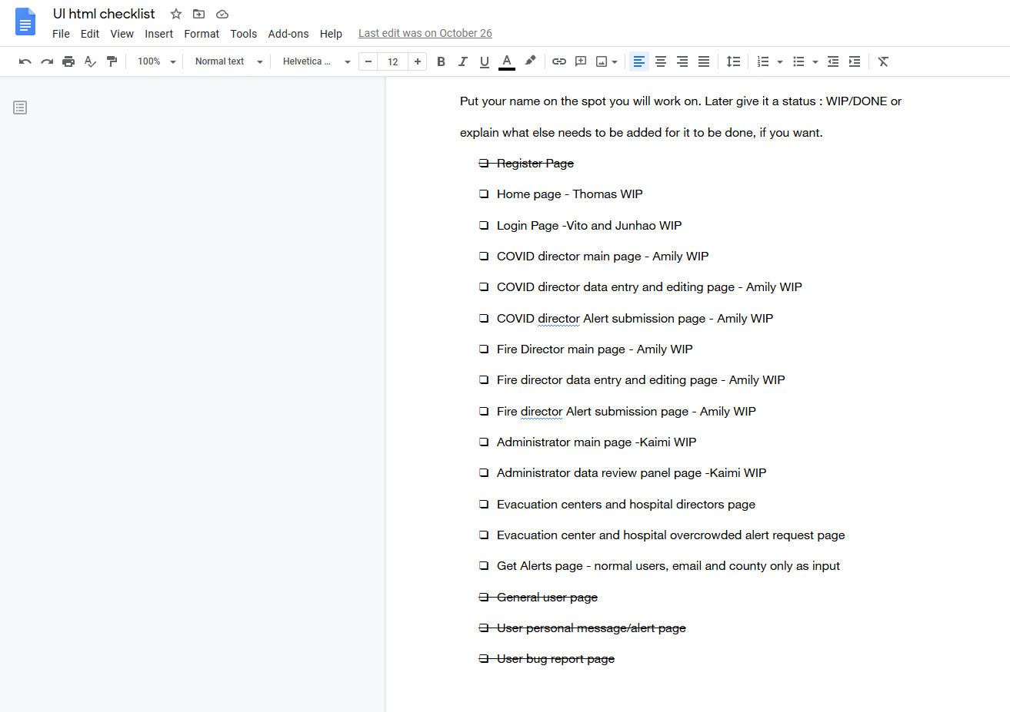

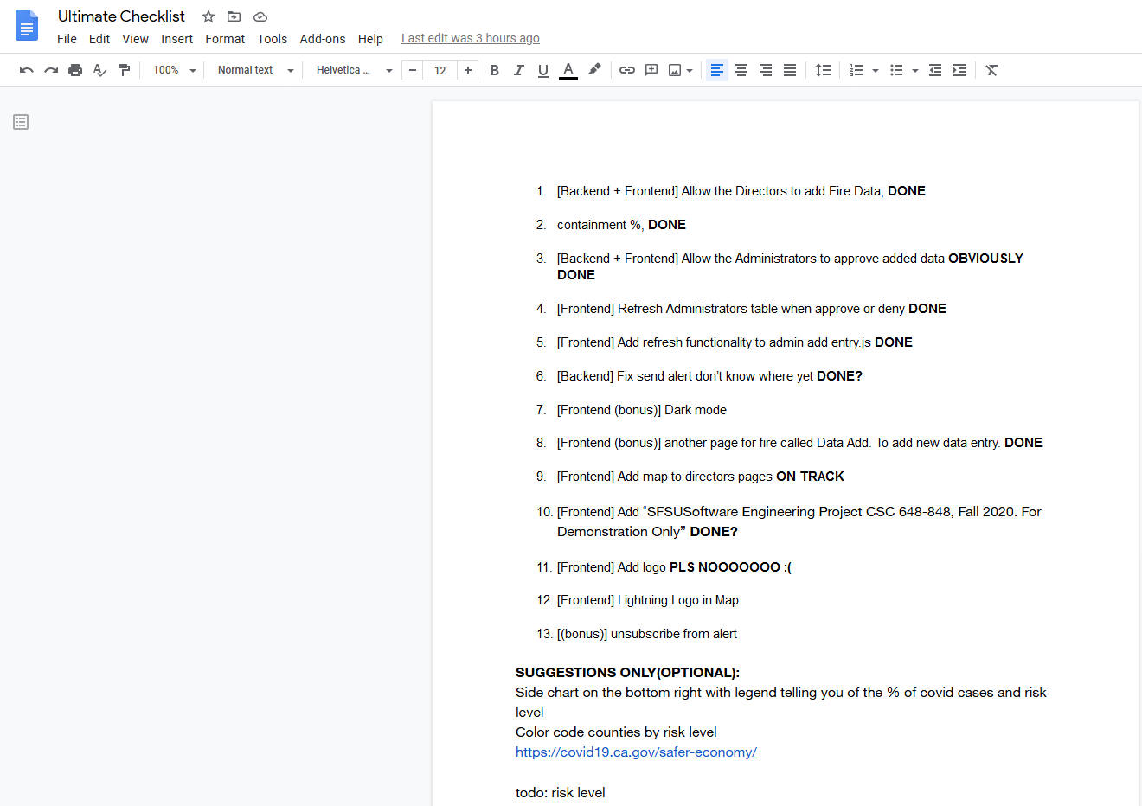

**8)Team member contributions**

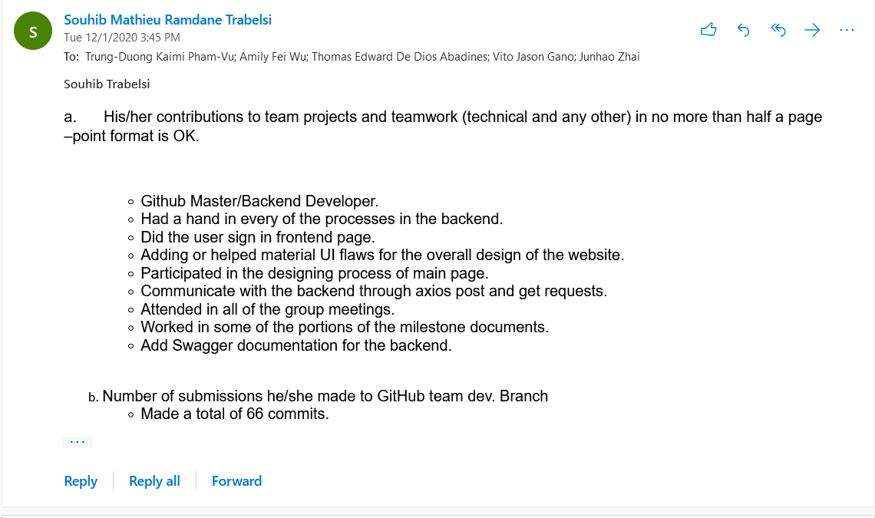

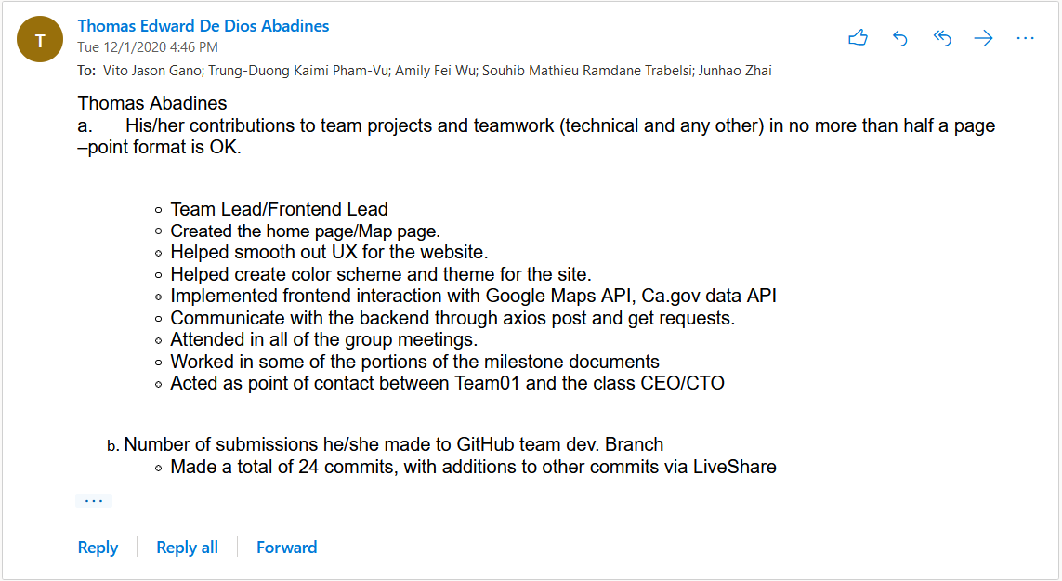

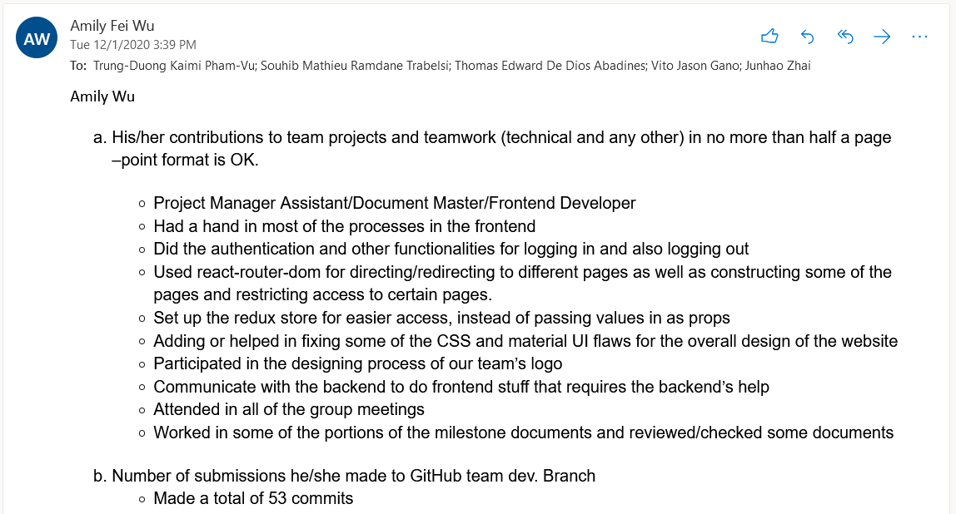

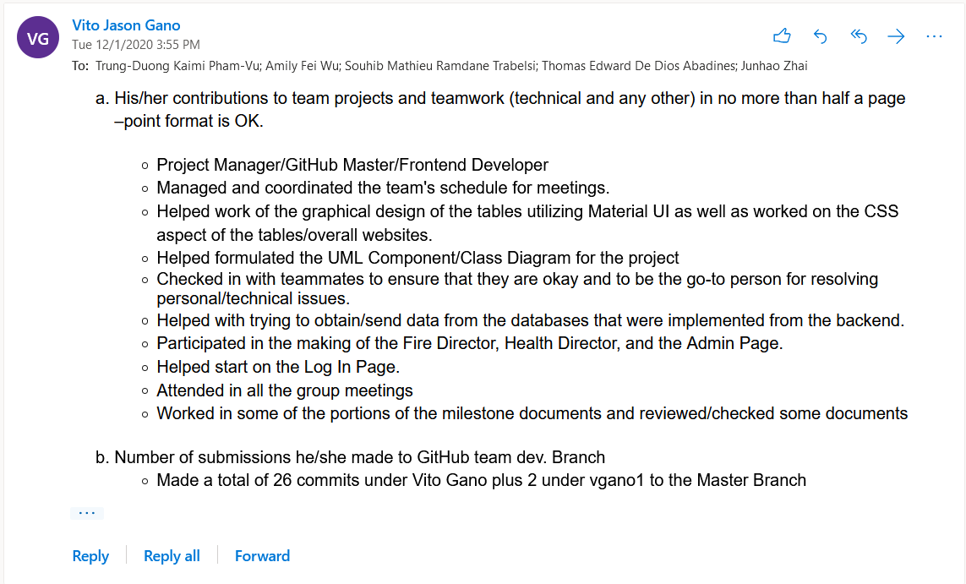

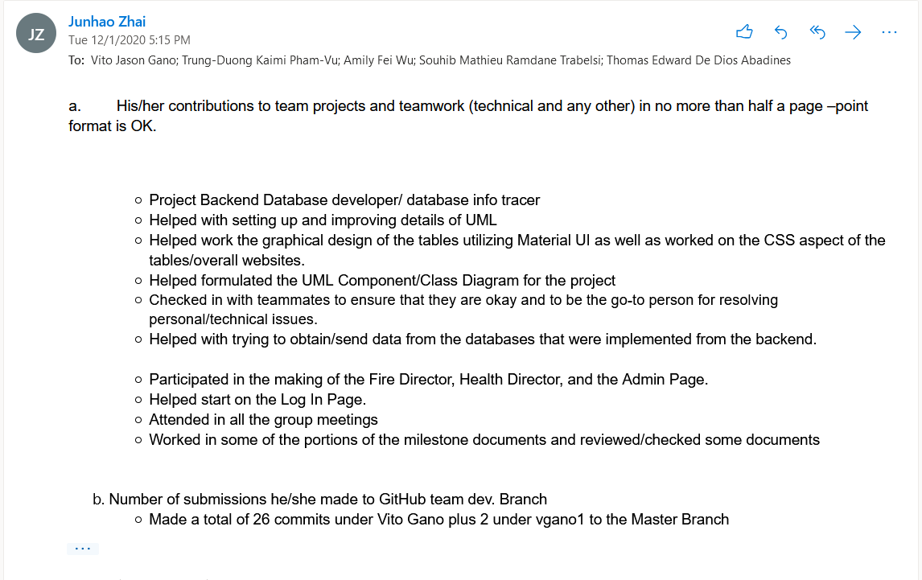

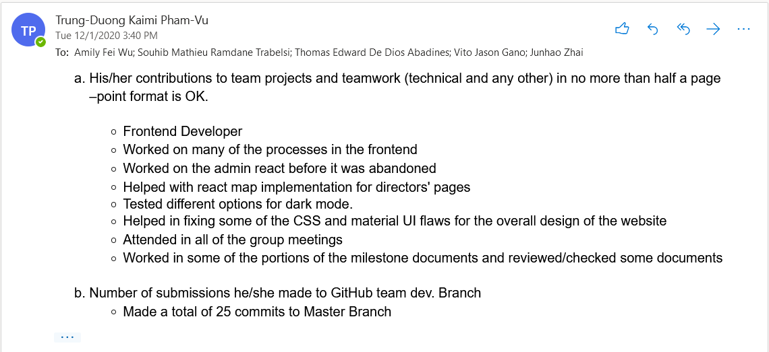

**9) Post analysis–lessons learned**

* Working in a team (especially debugging with the team together using LiveShare to see the issue), LiveShare was a very helpful tool to use.
* Meetings twice a week greatly helped with keeping base with everyone’s progress. The durations of the meetings were about 4-6 hours each.
* We learned how to build a React app from scratch using the material UI component library.
* We learned how to create a Flask API from scratch using Blueprint architecture to split routes into different python modules.
* We learned how to document and create a MySQL database.
* We learned which form of organization method (Agile) worked best for our group.
* We learned how to deploy an entire architecture composed of a React frontend app, a Flask backend API and a MySQL database on AWS services.
* We learned how to split tasks using Trello organization tool.
* Split work in branches on Github
* We acquired knowledge on how to build backend API with lightweight Flask framework. We saw how an API can retrieve data from HTTP requests and process it in that way, we send back information to the frontend application.
* We learned how to improve database ability as long with more user desired function
* We learned how to connect our React frontend app to another API through HTTP requests with Axios library. We’ve seen how to pass data through body parameters when making GET and POST requests
* We learned what are the different tools to document a backend API and we learned how to implement swagger to describe the routes of our Flask API
* Our Team used several means to communicate with each other while working on the project: Discord (mainly for voice chat, sharing screens), email (sharing feedback and answers from boss), Trello (for organizing tasks), Zoom (breakout sessions) and Whatsapp (for phone communication and announcements). This helped us stay organized and allowed us to swiftly address any concerns about the project.